Issue with task list after migrating workflows

We have migrated a list list was having workflow ,wf was migrated with list ,wf having approval task forms,when wf was migrated associated task list was not there with wf, we tried manually to assign task list and publish again bu no luck

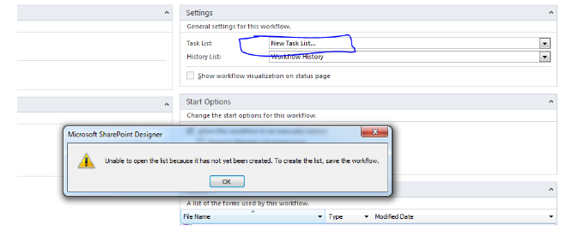

Solution---we deleted that wf from designer

Then connected to sharegate tool,copy structr connected source and target

Selecte list>>option>>select only workflow >>copy and replace>>completed>>then went to designer and checked>>workflow came to and checked associated task list is opening>> issue resolved

Refer this link-

https://social.technet.microsoft.com/Forums/office/en-US/cd9528e0-2ae1-4845-9464-6c9b41618e3a/issue-with-task-list-after-migrating-workflows-and-whole-site-as-well-using-sharegate?forum=sharepointgeneralprevious